NON-MALICIOUS MAIL PHISHING

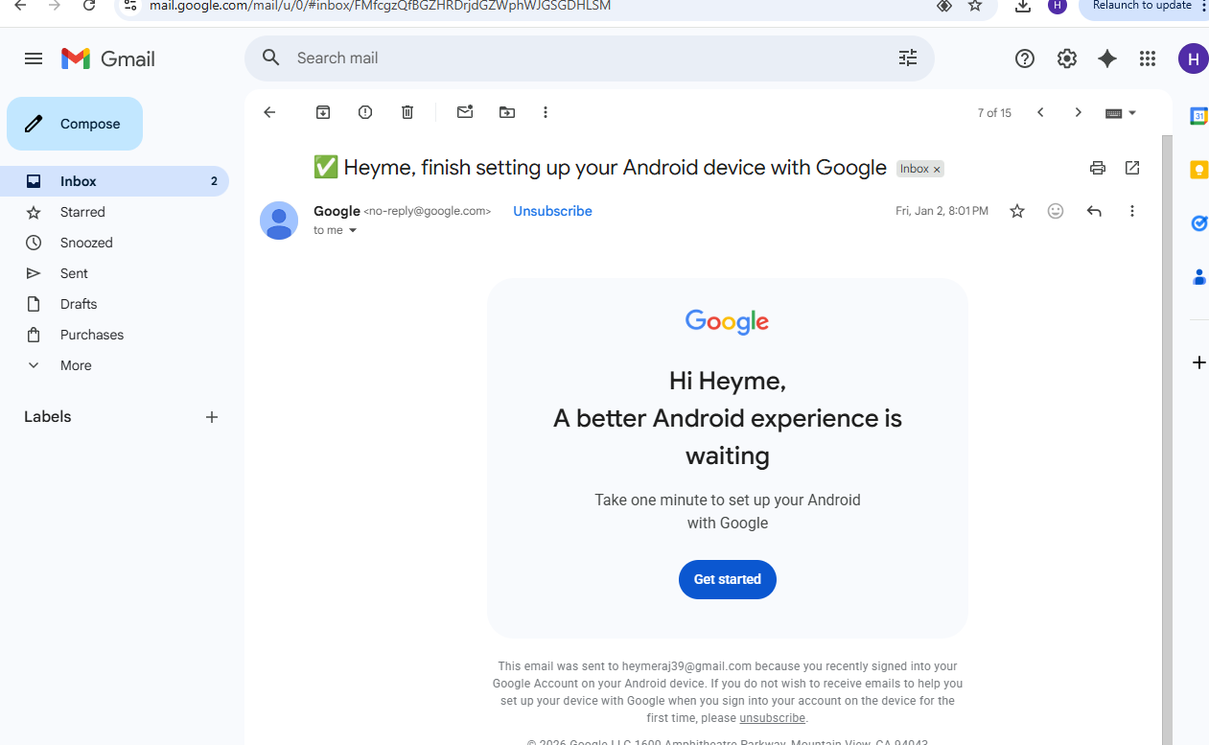

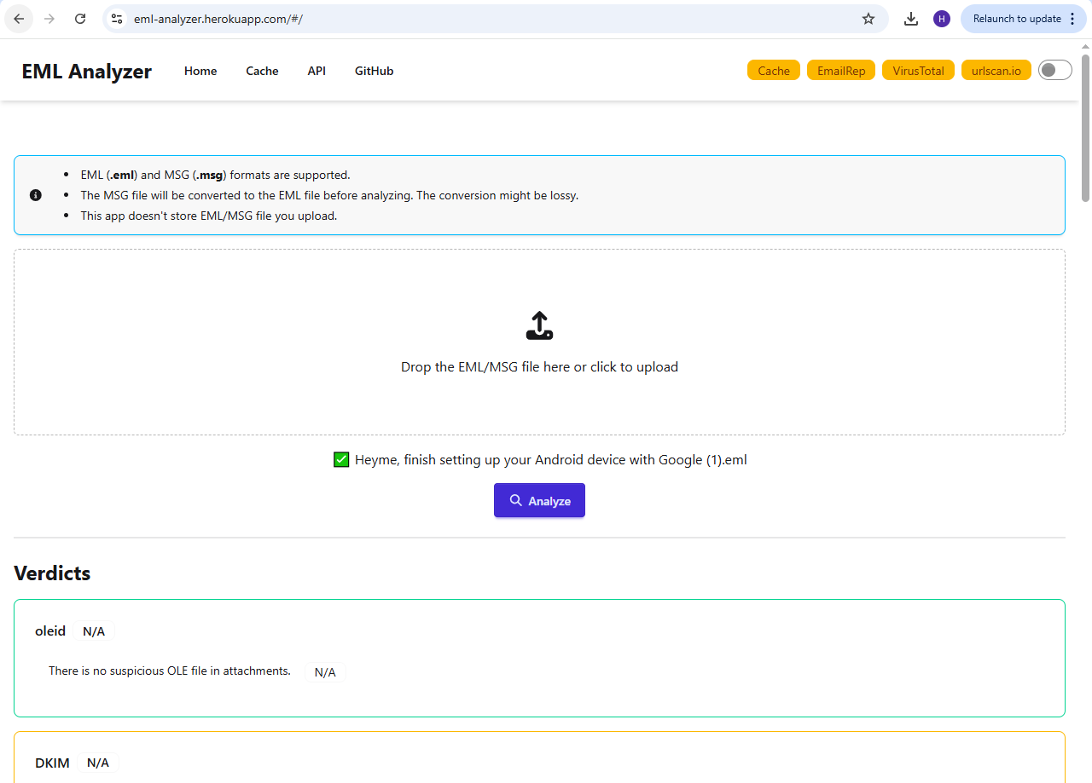
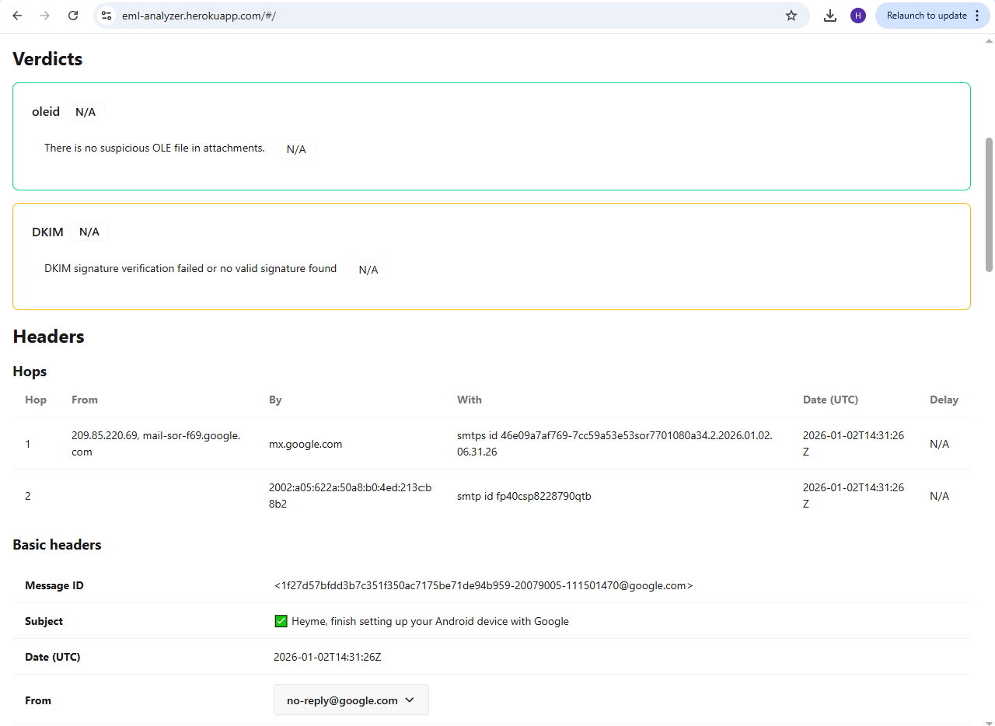
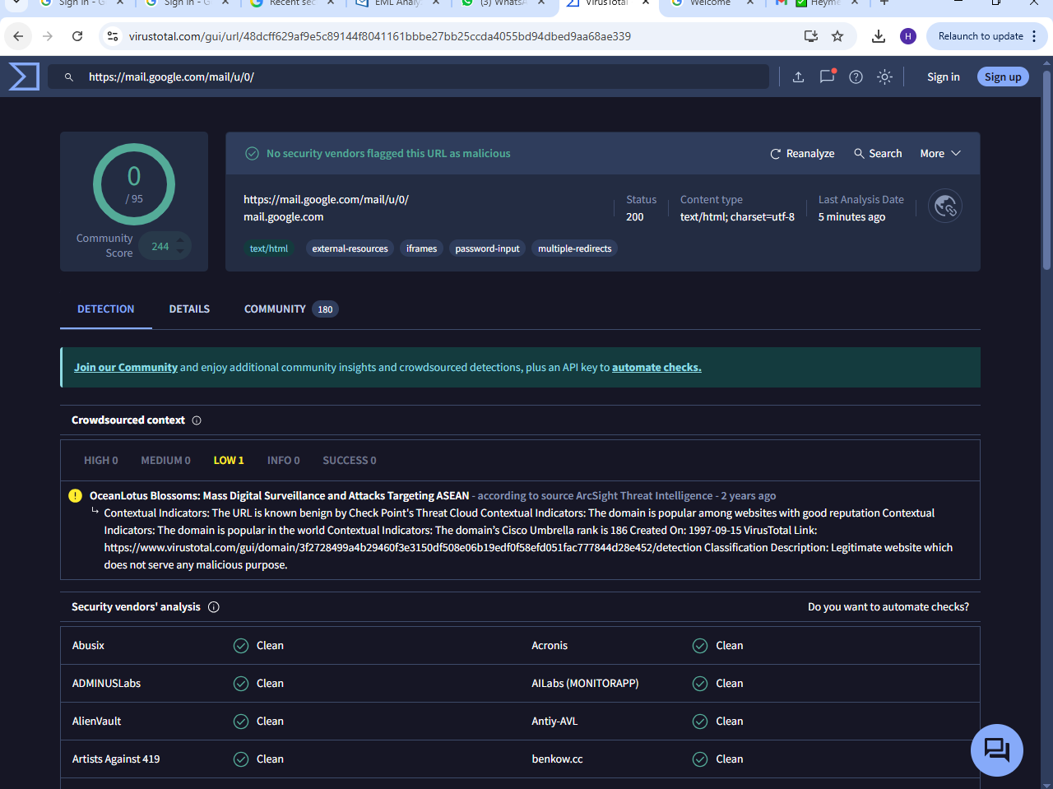

EXAMPLE 1 : MALICIOUS EMAIL PHISHING

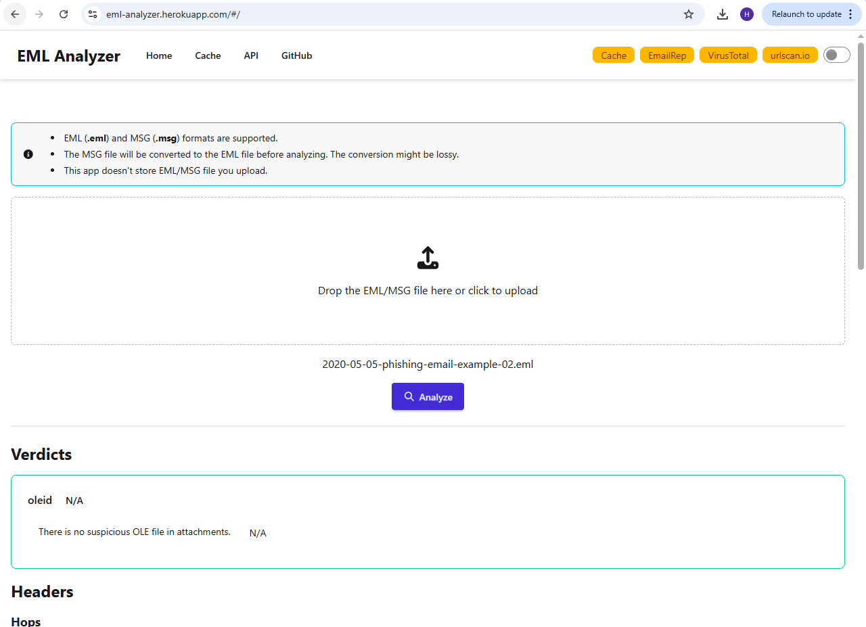

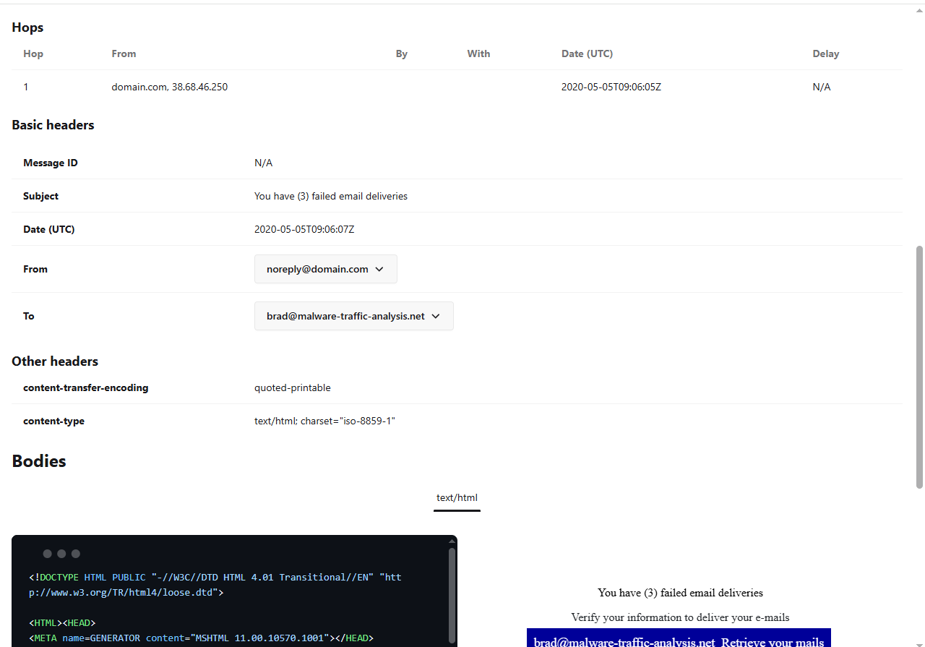

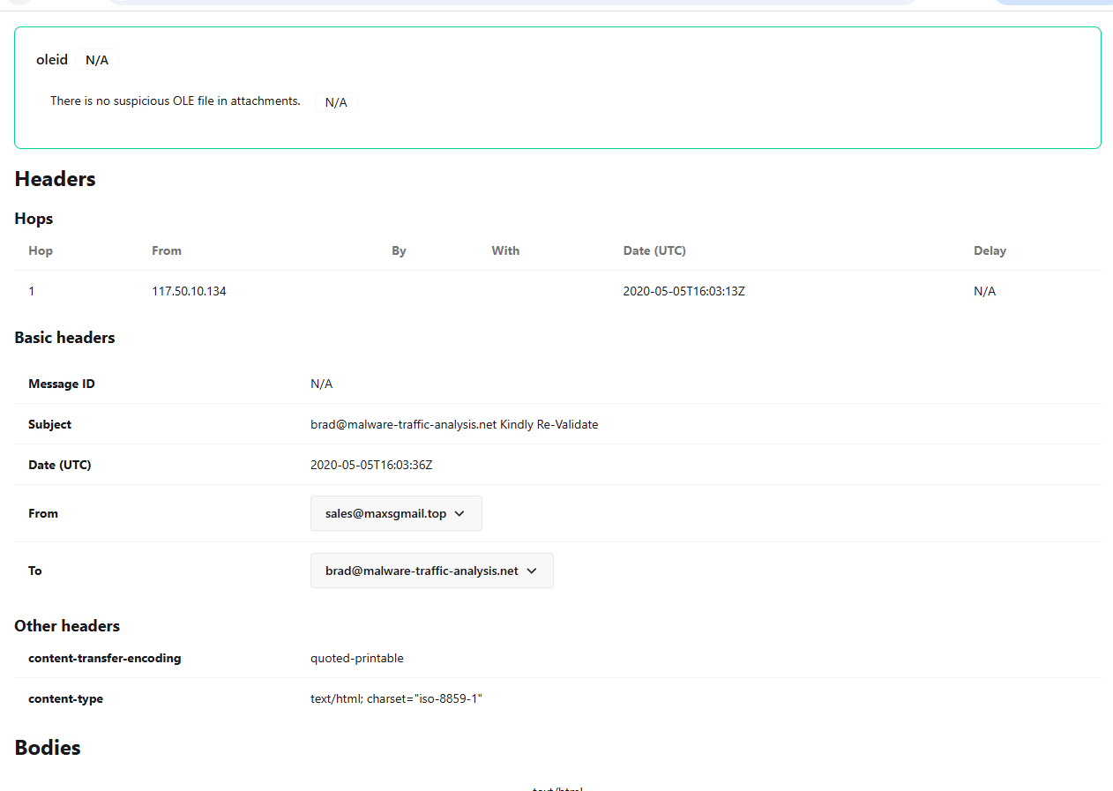

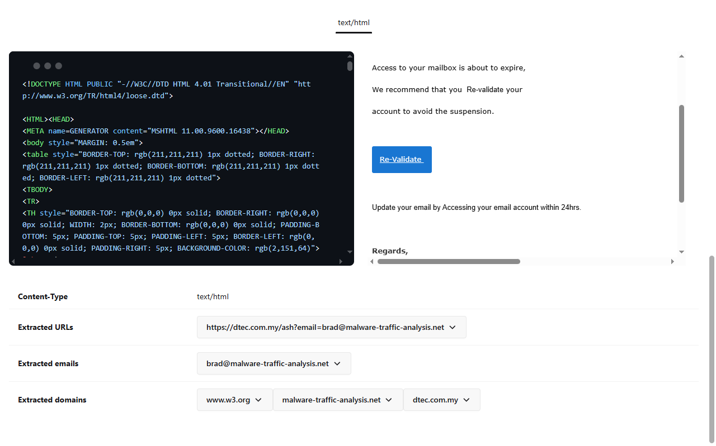

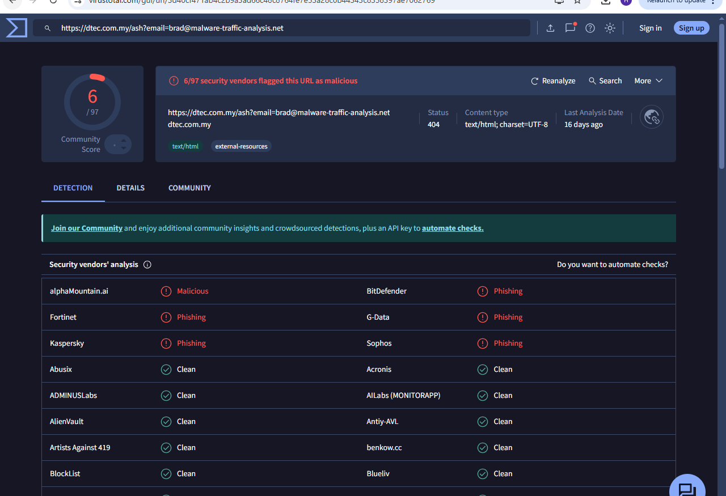

QUESTIONS AND ANSWERS
What is the full email address of the sender?
A: The full email address of the sender is noreply@domain.com

2. What domain is used to send this email?
A: The domain used to send this email is domain.com

3. What is the sender's IP address from the email?
A: The IP address of the sender is 37.68.46.240

4. Is the sender's IP blacklisted?
A: No, the sender's IP is not blacklisted.

5. What is the result of SPF authentication?
A: The result of the SPF authentication is PASSED.

6. What is one suspicious URL found in the email body?
A: There was only one URL extracted and it was marked as suspicious, malicious, and phishing.
The hidden URL is:
https://knu.edu.af/upgrade/vbd/a-l/admin_system/rules_404_sys/2019_nile_moves/ok_execute_2-2-1/now_g-a-m-e_starts/all-28-05-19/index.php?email=brad@malware-traffic-analysis.net

